Distribution System Analysis Subcommittee

IEEE 4 Node Test Feeder

IEEE 4 Node Test Feeder

The system to be use in testing transformer models is shown in Figure 1:
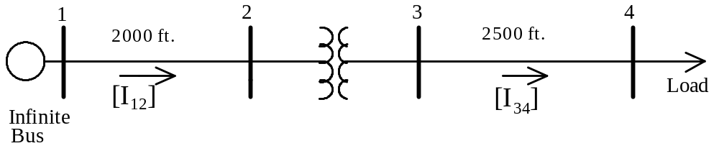
Figure 1 – IEEE 4 Node Test Feeder

Both the primary line (Node1-Node 2) and the secondary line (Node 3-node4) will be constructed using the pole configuration shown in Figure 2.

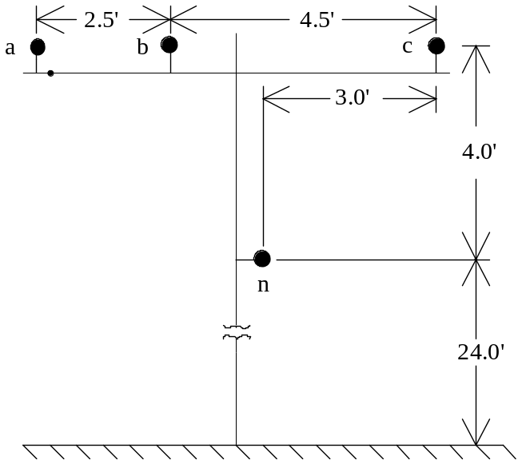
Figure 2 – Pole Configuration

Phase Conductor: 336,400 26/7
GMR = 0.0244 ft., Resistance = 0.306 Ω/mile, Diameter = 0.721 inch

Neutral Conductor: 4/0 6/1 ACSR
GMR = 0.00814 ft., Resistance = 0.592 Ω/mile, Diameter = 0.563 inch

The source is a 12.47 kV line-to-line infinite bus.

Three-Phase Transformer Data:

Connection | kVA | kVLL-high | kVLL-low | R - % | X - %
Step-Down | 6,000 | 12.47 | 4.16 | 1.0 | 6.0
Step-Up | 6,000 | 12.47 | 24.9 | 1.0 | 6.0

Open Wye – Open Delta:
(Two Single Phase Transformers Each Rated)

Connection | kVA | kV-high | kV-low | R - % | X - %
Step-Down | 2000 | 7.2 | 4.16 | 1.0 | 6.0
Step-Up | 2000 | 7.2 | 24.9 | 1.0 | 6.0

Closed Connections Load Data:

 | Balanced | Unbalanced

Phase-1
kW | 1800 | 1275
Power Factor | 0.9 lag | 0.85 lag

Phase-2
kW | 1800 | 1800
Power Factor | 0.9 lag | 0.9 lag

Phase-3
kW | 1800 | 2375
Power Factor | 0.9 lag | 0.95 lag

Open Connection Load Data:

 | Balanced | Unbalanced

Phase-1
kW | 1200 | 850
Power Factor | 0.9 lag | 0.85 lag

Phase-2
kW | 1200 | 1200
Power Factor | 0.9 lag | 0.9 lag

Phase-3
kW | 1200 | 1583.33
Power Factor | 0.9 lag | 0.95 lag

Loads are connected in grounded wye for four wire line configurations and connected in closed delta for three wire line configurations.

Line Impedances

4-wire configuration:

Phase impedance matrix:
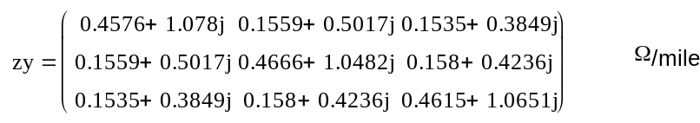

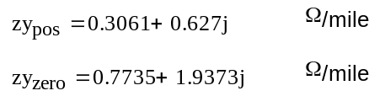
Sequence impedances:

Three wire configuration:

Phase impedance matrix:
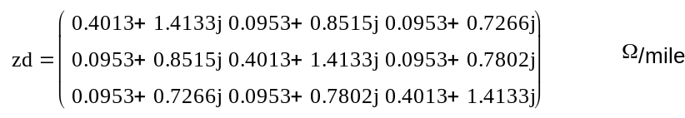

Sequence impedances:
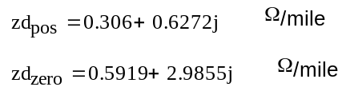

Standard Wye-Delta and Delta – Wye Connections

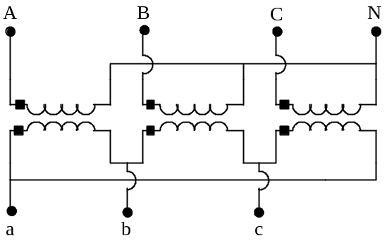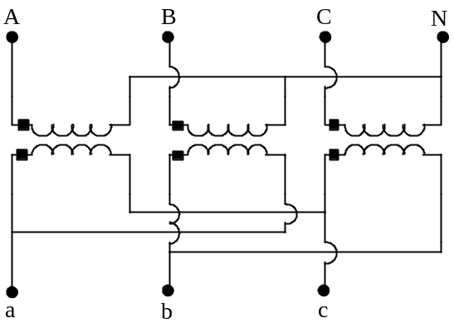

Wye-Delta Step Down Wye – Delta Step Up

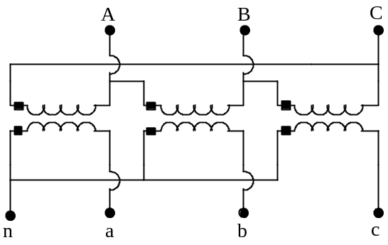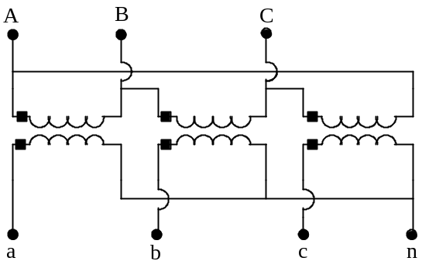

Delta – Wye Step Down Delta - Wye Step Up

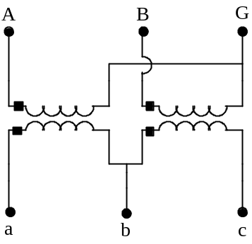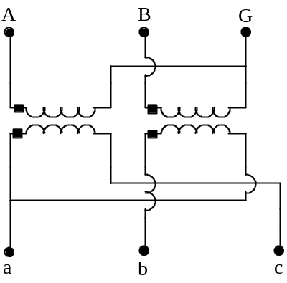

Open Wye-Delta Step Down Open Wye-Delta Step Up

Solutions

